Zelosity Business Use Case, Test Cases, and Continuity Guide
Invite-only WhatsApp login, GST-inclusive memberships, pay-first attendance, administrator control, and service continuity
Guide field | Value
Prepared for | Zelosity / Heal With Apurvaa client stakeholders and operations team
Prepared by | Zelosity
Version date | 12 September 2026
System scope | Public website, invite-only WhatsApp member login, GST-inclusive memberships, pay-first attendance, member dashboard, and administration
Staging URL | https://test.invictusnxtgen.in
Current launch position | Staging is live on Hostycare. Use the Meta test account until #131005 is cleared, the invite Utility template is approved, and Resend domain is verified. Do not move the new business number to production until it is Connected.

Purpose and main recommendation
This guide explains how a customer moves from a first website visit to a booking or enquiry request, studio activation of WhatsApp login, first-login onboarding, payment, attendance, and administrator follow-up. It includes current staging screenshots and the acceptance test cases that must pass before production.
Main recommendation: there is no open self-registration. Visitors request from Contact; the studio reviews the enquiry or booking and clicks Activate WhatsApp login; the member then signs in with that same number. Keep the existing WhatsApp Business App number for human chats. Use Cloud API only for OTP and approved templates. Do not go live until Meta #131005 is resolved, the invite Utility template is approved, and Resend uses a verified domain.
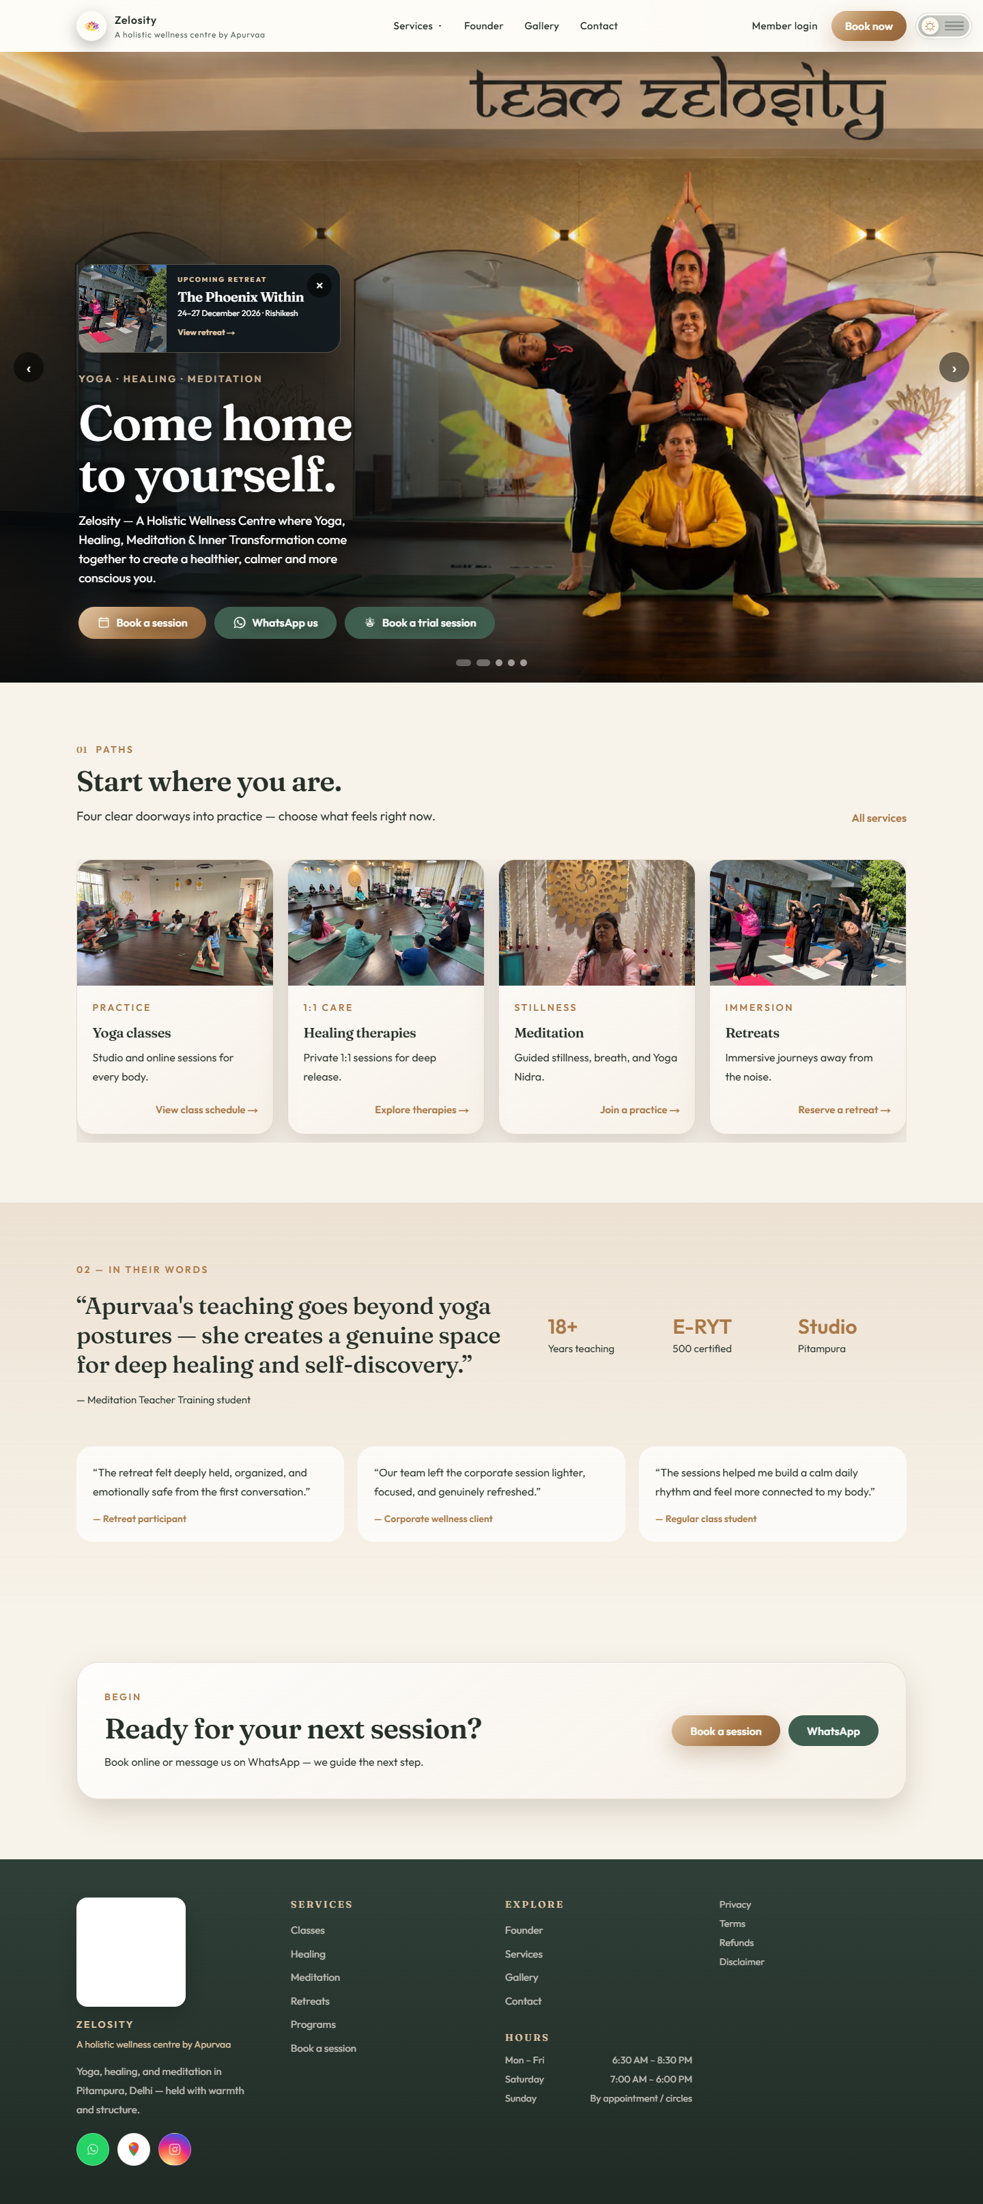
Figure 1. Staging home page (Zelosity first, Apurvaa as founder) — https://test.invictusnxtgen.in
Figure 2. Staging home page on a mobile viewport

Business actors and responsibilities
Actor | Primary responsibility | System access
Visitor | Browse services and submit a booking or inquiry. Cannot create a member account. | Public pages only
Member | Sign in only after studio activation, complete onboarding once, view matching records, pay, and mark attendance after payment. | Member dashboard after OTP and onboarding
Administrator | Review requests, Activate WhatsApp login, confirm or waitlist bookings, record payment, issue memberships, and open attendance QR. | Team login and protected admin workspace
Zelosity application | Validate input, store business records, generate secure OTP challenges, create sessions, and enforce access rules. | Application and database
Meta WhatsApp Cloud API | Deliver approved WhatsApp authentication templates and return provider responses. | External provider
Client operations team | Own customer communication, approve manual exceptions, verify offline payments, and manage incidents. | Admin workspace plus existing communication channels

System boundary
- The website database is the source of truth for bookings, payment status labels, passes, inquiries, check-ins, certificates, and login sessions.
- WhatsApp is a delivery channel for the one-time login code and selected service notifications. A WhatsApp outage does not delete application records.
- The client’s original WhatsApp chat history stays in the original WhatsApp Business App. It is not imported into the website database.
- The new Cloud API number is separate from the original mobile-app number. This separation protects the client’s existing chats and calls.

Current number onboarding position
Asset | Observed state | Operational decision
Existing WhatsApp Business App number ending 3966 | Existing customer calls and chats | Keep unchanged and use as the continuity contact channel.
New Cloud API number ending 91012 | Added to the Apurvaa Saxena WABA; screenshot showed Pending and display name In Review | Do not route production authentication through it until Meta shows Connected and required approvals are complete.
Meta test number ending 1529 | Connected test asset | Use only for staging recipients and end-to-end technical verification.

Normal end to end business use case
The locked operating flow is Visitor to Request to Studio Review to Activate WhatsApp Login to OTP to Onboarding to Payment to Attendance. There is no open self-registration.
Step | Owner | Action | Expected result
1 | Visitor | Open the website and review services, classes (GST-inclusive prices), therapies, programs, retreats, and policies. | Public content is available without authentication.
2 | Visitor | Submit Contact booking or enquiry with name and WhatsApp number. Do not expect an instant account. | Request is stored as Requested / New. No member login is created yet.
3 | Application | Save the request even if WhatsApp delivery is down. | The studio does not lose the lead.
4 | Administrator | Review the enquiry or booking. Confirm, waitlist, or keep requested. | Status updates. Confirmation does not collect payment.
5 | Administrator | Click Activate WhatsApp login on that request. | A member account is invited for that exact phone. If Cloud API cannot send the invite, share the preview message manually.
6 | Member | Open Member login and enter the same WhatsApp number. Request a code. | Unactivated numbers are rejected. Activated numbers receive the Authentication OTP template.
7 | Member | Enter the six-digit code within 10 minutes. | Session starts. First login goes to onboarding.
8 | Member | Confirm name, optional email, language, and accept Terms plus Privacy once. | Profile is complete. Dashboard shows that member’s enquiry, payments, receipts, and attendance.
9 | Administrator | Set amount and payment status, or the member pays online when enabled. | Attendance stays locked until paid, advance_paid, or an active pass exists.
10 | Member / Admin | Scan the studio or class QR after payment. | One AttendanceRecord is written. Admin roll and member profile show the same present row.
11 | Member | Request reschedule or cancellation with a reason. | Admin approves or rejects. Payment is handled separately.
12 | Both | Sign out. Follow up using the request identifier. | Session ends. Records remain stored.

WhatsApp login controls
- Each login challenge expires after 10 minutes.
- Generating a new code invalidates any earlier unconsumed code for the same phone number.
- A challenge is blocked after five unsuccessful verification attempts.
- Code requests are limited to five in 15 minutes per client key; verification requests are limited to twelve in 15 minutes.
- Successful verification creates a 14-day application session unless the user signs out earlier.
- Local developer codes are for localhost testing only and must be disabled on every public or production URL.

Administrator operating use cases
Business situation | Administrator action | Important boundary
New booking or enquiry | Review details. Confirm, waitlist, or leave requested. Then Activate WhatsApp login when the person should be allowed in. | Activation creates the member identity. It does not collect payment.
WhatsApp invite fails to send | Share the on-screen preview message from the studio WhatsApp. Do not activate again unless the number changed. | Login is already enabled. Delivery failure is a Meta/template issue.
Class or session is full | Set capacity and move the request to the waitlist; promote it when capacity becomes available. | Do not confirm more seats than operations can serve.
Member requests a date or mode change | Approve to apply the new date or mode, or reject and keep existing details. | Capacity rules are reapplied when the change is approved.
Member requests cancellation | Approve the cancellation and retain the record in Closed bookings. | Cancellation does not automatically refund a paid amount.
Offline payment received | Verify the receipt outside the system, then update the payment label to Advance paid or Paid. | The label is record keeping only; it does not move money.
Online payment requires refund | Use the dedicated refund action when a valid Razorpay payment exists. | Marking Refunded manually must follow actual offline settlement; never use the label as a substitute for returning funds.
Member cannot log in | Verify the incident, continue managing the member’s booking, and communicate through the original WhatsApp number or telephone. | The current admin workspace cannot bypass the OTP or impersonate the member.
WhatsApp notification fails | Contact the member manually and continue the booking workflow in the admin system. | Do not repeatedly trigger messages without checking provider status and rate limits.
Member account needs investigation | Use booking, inquiry, audit, and notification records to understand the business history. | Current admin member lookup is email-oriented; phone-only account recovery needs a dedicated enhancement.
Incorrect record must be corrected | Use reversible status changes where possible and preserve the audit trail. | Use Delete only for genuinely erroneous test or duplicate data, not as a substitute for cancellation.

What an administrator can override today
Control | Available | Meaning
Booking status | YES | Confirm, waitlist, return to requested, or cancel while retaining the record.
Capacity | YES | Change the number of seats and promote a waitlisted booking when space is available.
Booking amount | YES | Correct the amount shown as due; this does not collect money.
Payment status label | YES | Record Pending, Advance paid, Paid, or Refunded after financial verification.
Member change request | YES | Approve or reject reschedule and cancellation requests.
Passes and certificates | YES | Manage credits and issue or revoke eligible certificates.
Activate WhatsApp login | YES | Invites that exact phone so the member can request an OTP. Does not reveal the OTP.
Member WhatsApp OTP | NO | The administrator cannot view, invent, bypass, or approve a member OTP.
Attendance without payment | NO | QR check-in requires paid, advance_paid, or an active membership pass.
Meta number status or display-name approval | NO | Only Meta can change Pending, Connected, or review outcomes.
Actual payment or refund by changing a label | NO | Money movement must occur through Razorpay or a verified offline process.
Deleted record recovery | NO | Deletion is permanent in the application; use cancellation for normal operations.

When WhatsApp integration does not work
The administrator should first preserve the customer’s booking and service outcome, then diagnose the delivery channel. Do not deregister the client’s existing WhatsApp number, delete a WABA, expose an access token, or enable local developer codes on a public site as a troubleshooting shortcut.
Failure scenario | Customer impact | Administrator workaround | Technical resolution
New number remains Pending or display name remains In Review | Production OTP cannot be trusted on the new number. | Keep the website on the Meta test setup for staging and use the original business number for client communication. | Complete phone verification and registration, then wait for Connected status and required approvals.
Access token is missing, expired, or unauthorized | The Send code action returns a temporary failure. | Process bookings manually and notify members through the original WhatsApp number or phone. | Issue or refresh the production token through the approved system-user process, store it as a server secret, restart, and retest.
Phone Number ID and token belong to different assets | Meta rejects the request. | Do not retry repeatedly. Continue manual communication. | Copy the Phone Number ID for the selected WABA and ensure the token has access to that same account and number.
Authentication template is missing, rejected, paused, or mismatched | OTP message is not delivered. | Use manual booking support; do not send the OTP as an unapproved free-form message. | Approve an Authentication template and match its name, language, body variable, and copy-code button to the application configuration.
Test recipient is not allowlisted | Staging message is rejected even though the test sender is Connected. | Add only an authorized test recipient or use an already approved recipient. | Complete production onboarding before testing unrestricted recipients.
Member enters an invalid number | No challenge is created. | Ask the member to include the country code and confirm the reachable WhatsApp number. | Use E.164 formatting such as +91 followed by the ten-digit Indian number.
Code is incorrect, expired, reused, or locked | Member cannot complete login. | Ask the member to request one new code and use only the latest message. | Wait for the resend control, verify the server clock, and investigate repeated failures without disclosing the code.
Rate limit is reached | Further requests are temporarily rejected. | Stop retries and assist the member manually during the waiting period. | Wait for the 15-minute window and investigate automated or abusive traffic.
Meta or network outage | WhatsApp delivery is unavailable for multiple members. | Keep accepting bookings; manage them in Admin; contact customers using the existing WhatsApp Business App, phone, or approved email channel. | Monitor provider recovery and run a single controlled health test before restoring automated sends.
Member changed or lost the registered phone | Dashboard access is unavailable for that identity. | Verify identity using the client’s approved offline process and continue service manually. | Implement a secure phone-change or recovery workflow; current production behavior does not permit an admin OTP bypass.
Application or database is unavailable | The OTP may arrive but cannot be verified, and business records are unavailable. | Use the continuity contact channel and avoid promising that a booking is saved until the system is restored. | Restore the application and database, validate migrations, then reconcile any manually recorded requests.
Payment provider is unavailable | Online payment cannot complete. | Keep the booking Requested or Confirmed based on policy and collect through an approved offline method if the client authorizes it. | Reconcile the payment before changing the label; never create a paid or refunded status without evidence.

Continuity procedure for administrators
1. Acknowledge the member and capture the booking or support request in the application if the application is available.
2. Check whether the problem affects one phone number or all members. Do not ask the member to share the OTP with the administrator.
3. Open the Admin readiness view and confirm whether WhatsApp authentication configuration is Ready, Warning, or Blocked.
4. Check the new number’s Meta status, the selected Phone Number ID, token authorization, and authentication-template status.
5. Run one controlled delivery test to an approved recipient. Stop repeated retries if Meta returns a configuration or rate-limit error.
6. If delivery remains unavailable, activate the manual communication process using the original WhatsApp Business App number, phone, or approved email.
7. Continue booking decisions, capacity management, change requests, and verified offline payment recording in Admin.
8. Record the incident start time, affected member or booking identifiers, provider error, workaround used, and final resolution. Never record tokens or OTP values.
9. After recovery, send one health-check OTP, verify login, reconcile manually handled bookings, and close the incident.

Safe fallback design recommended for production
The following capabilities are recommended enhancements. They are not currently presented as existing administrator functions.
Recommended capability | Business value | Required safeguards
Email OTP fallback | Allows a verified member to sign in when WhatsApp delivery is unavailable. | Verified email, ten-minute expiry, one-time use, rate limits, and the same audit and session controls as WhatsApp.
Administrator-issued recovery link | Supports exceptional account recovery after identity verification. | One-time link, short expiry, stated reason, audit event, administrator confirmation, and no ability to reveal the member’s OTP.
Secure phone-change workflow | Lets a member move from an old number to a new one. | Verify at least one trusted factor, notify the old contact where possible, prevent duplicate account merging, and log the change.
Provider health and fallback banner | Explains an outage and offers approved contact options before users repeatedly retry. | No sensitive provider details; administrator-controlled activation and automatic expiry.
Phone-based admin lookup | Lets support locate a phone-only member account and its business records. | Admin authorization, masked search results, audit logging, and no impersonation control.
Manual contact log | Preserves what the studio communicated during an outage. | Record channel, time, outcome, and booking reference; never store OTPs or access tokens.

Fallback priority
Priority | Method | Production status
1 | Restore WhatsApp Cloud API delivery and use the normal OTP flow. | Preferred
2 | Use a verified email OTP after the recommended fallback is implemented. | Not currently implemented
3 | Use a one-time audited recovery link after identity verification and implementation. | Not currently implemented
4 | Provide manual service through the existing WhatsApp Business App, phone, or email while keeping admin records current. | Available operational workaround
Never | Expose local developer codes, share an administrator login, reveal OTPs, or create a permanent universal bypass. | Prohibited

Service commitments during fallback
Commitment | Client-facing behavior
Preserve the request | Capture the booking or inquiry in the application whenever it is available, even if WhatsApp delivery is down.
Use the continuity channel | Respond through the client’s existing WhatsApp Business App number, telephone, or approved email address.
Protect authentication | Never ask a member to disclose an OTP and never share a team login or local developer code.
Keep financial records honest | Change payment labels only after the underlying payment or refund has been verified.
Reconcile after recovery | Link any manually handled request to its application record and confirm the final member-visible status.

Current staging screenshots
Captured 12 September 2026 from https://test.invictusnxtgen.in after the Zelosity / invite-only / GST merge. Use these figures with P11–P18 and N13–N18.
TC-HOME. Public home — Zelosity branding, no login required.
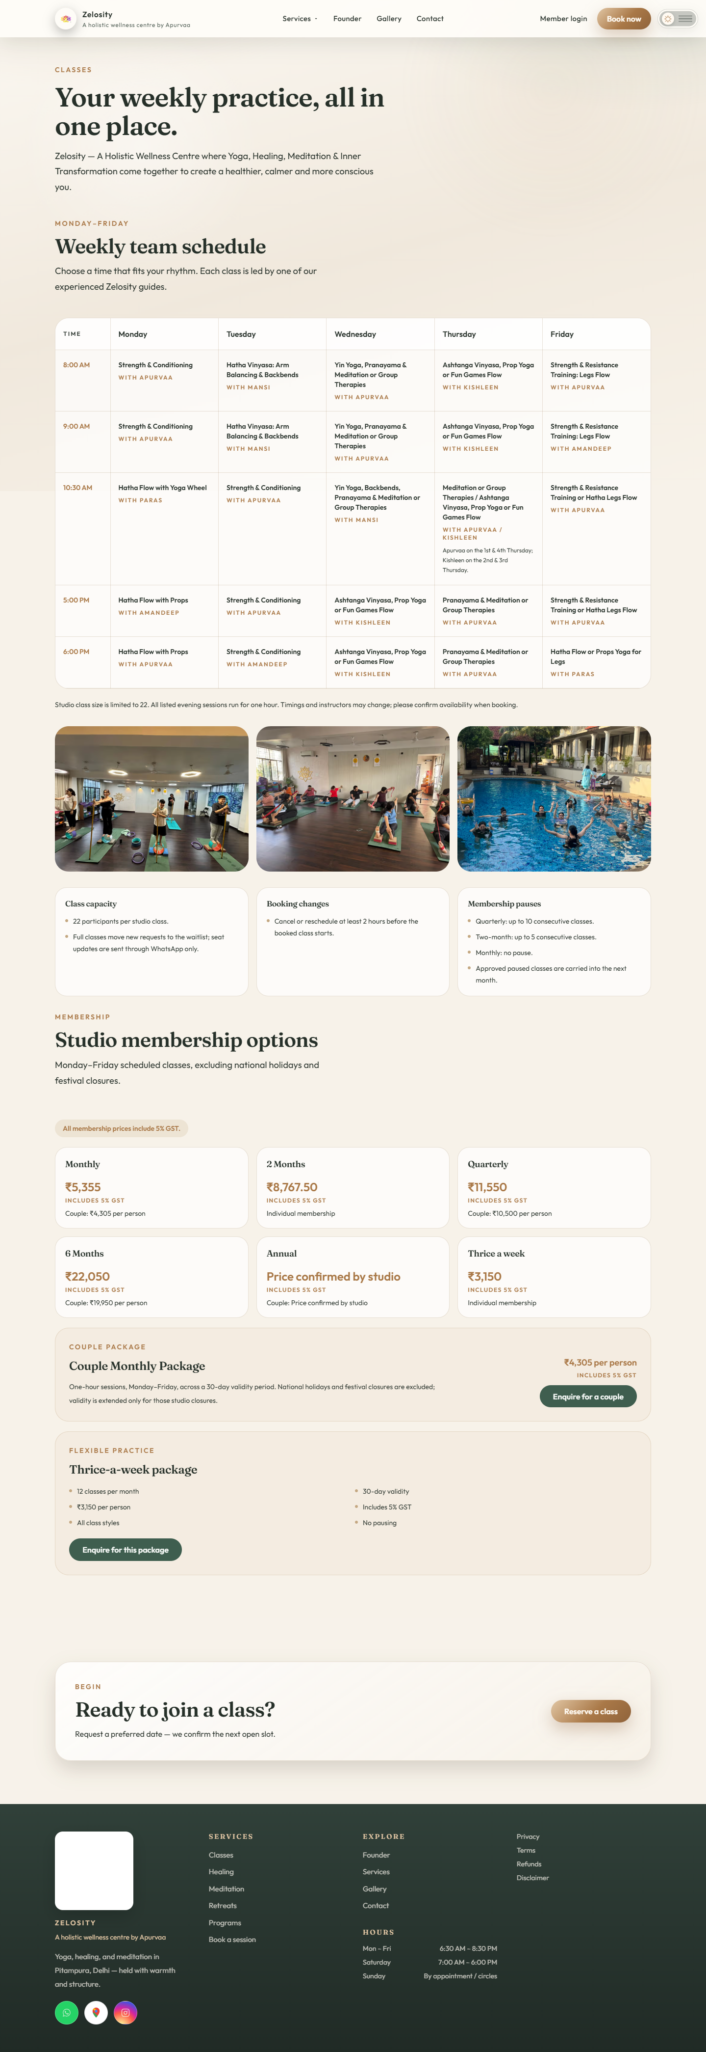
TC-GST. Classes — membership prices include 5% GST.
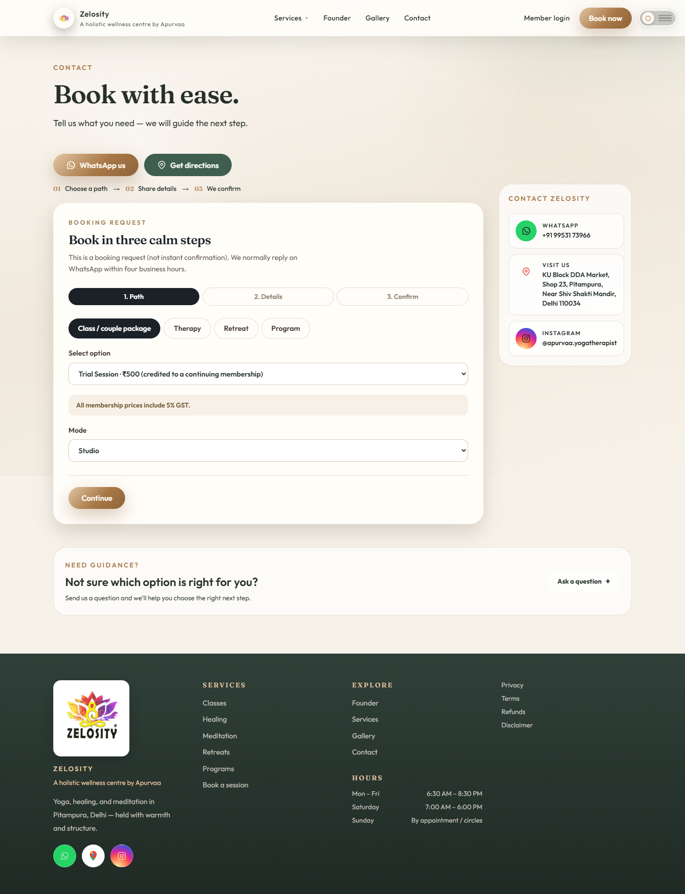
TC-REQ. Contact request is the only path into the studio.
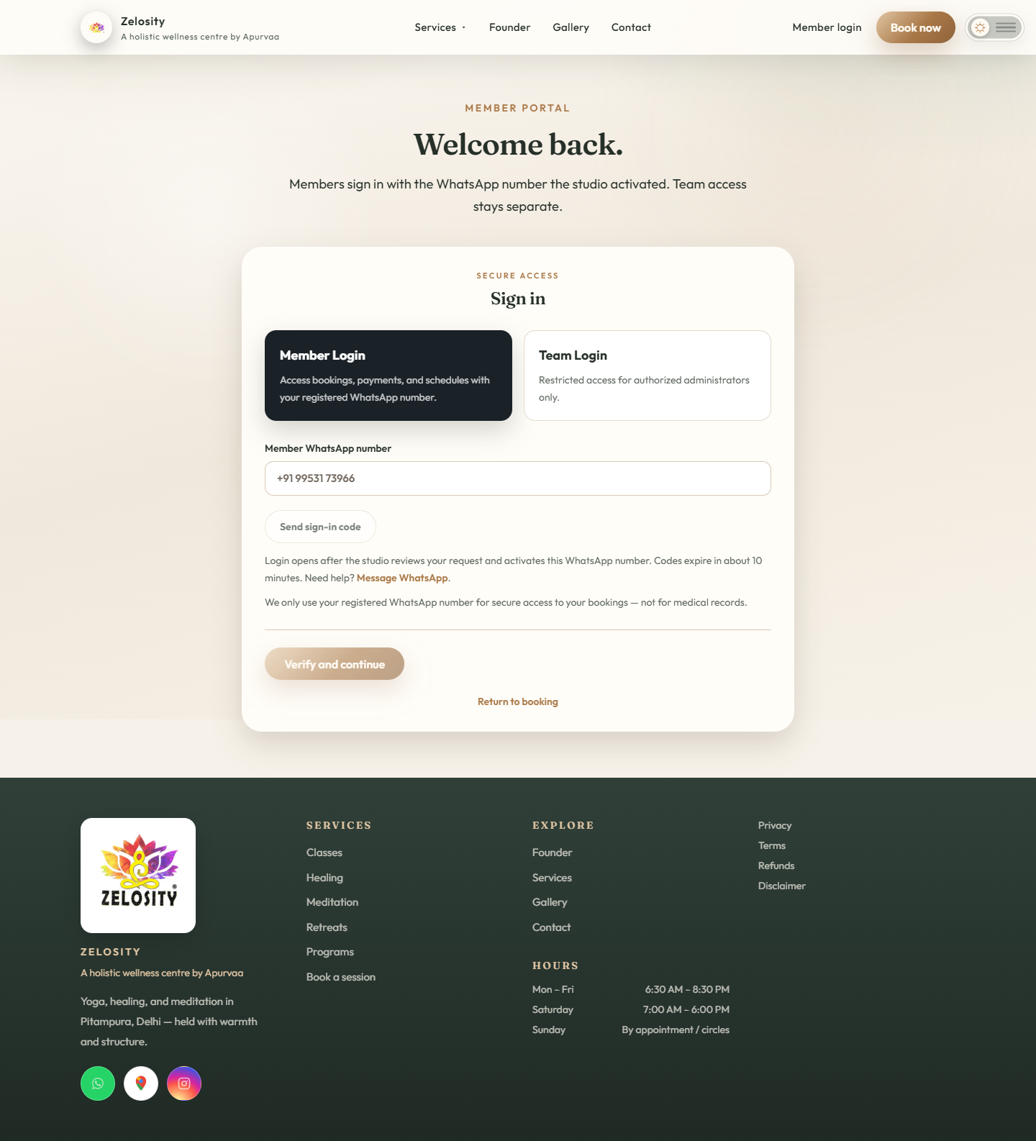
TC-LOGIN. Member login copy states the number must already be activated.
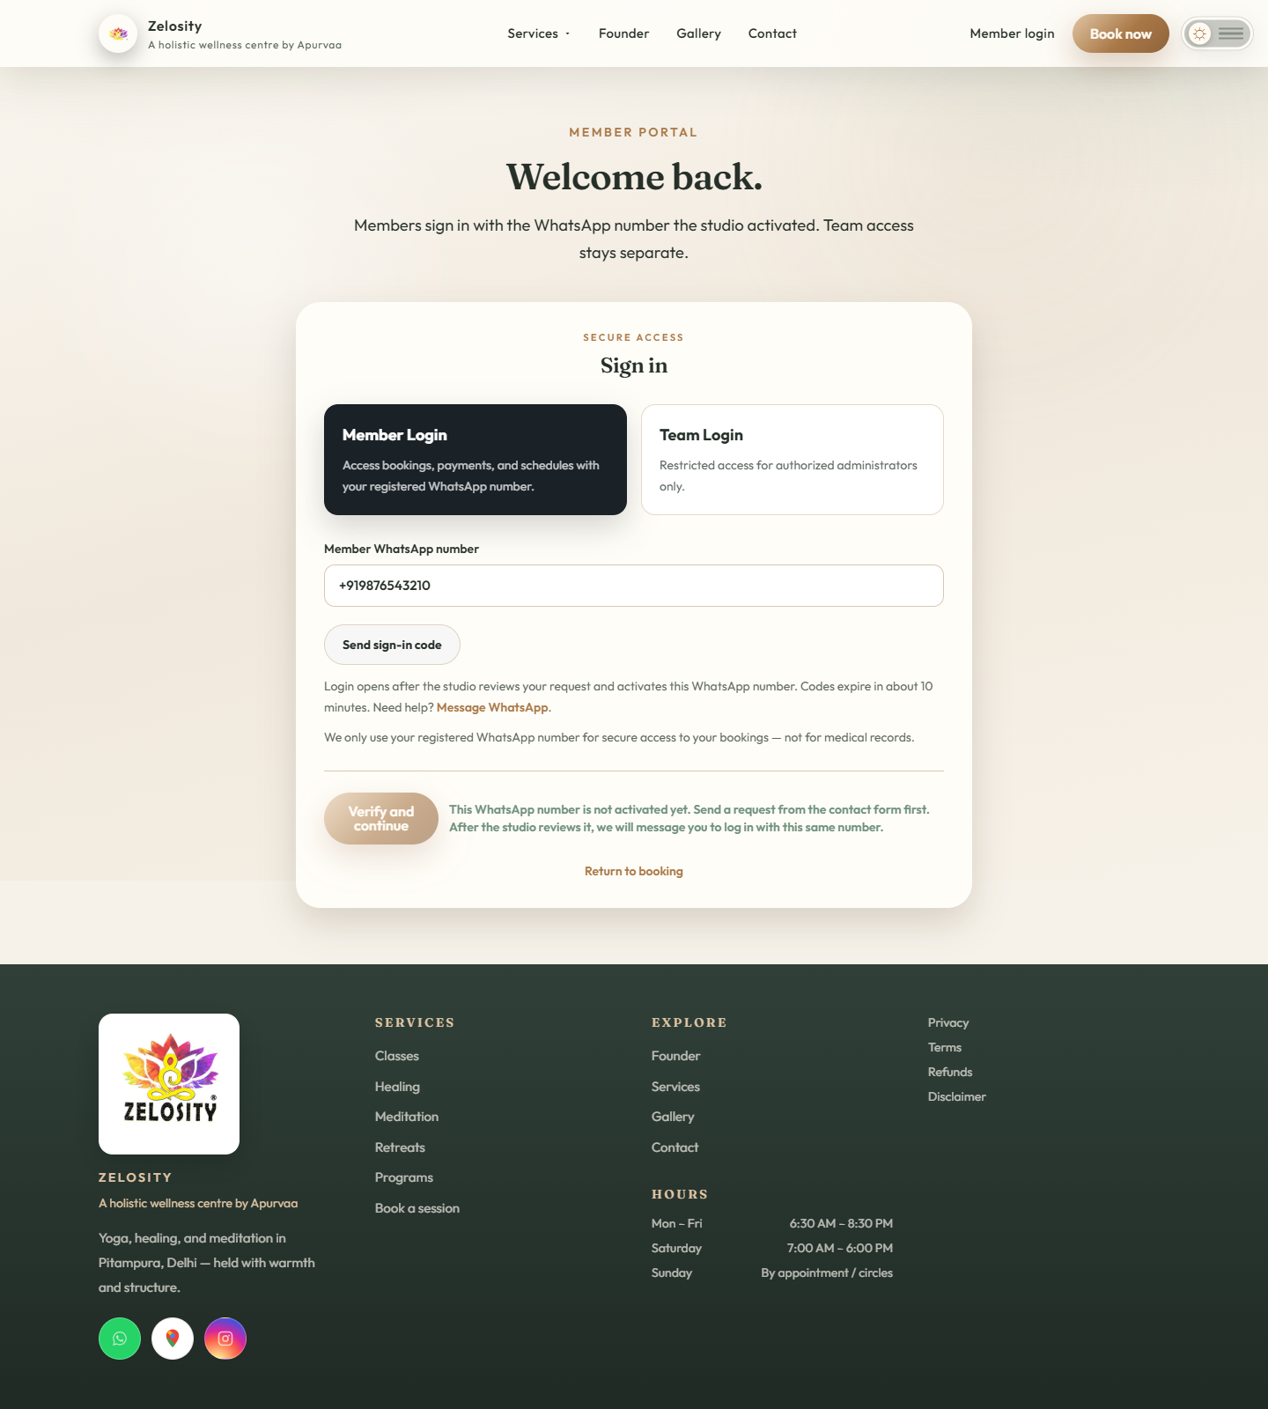
TC-N13. +91 98765 43210 is rejected until Activate WhatsApp login.
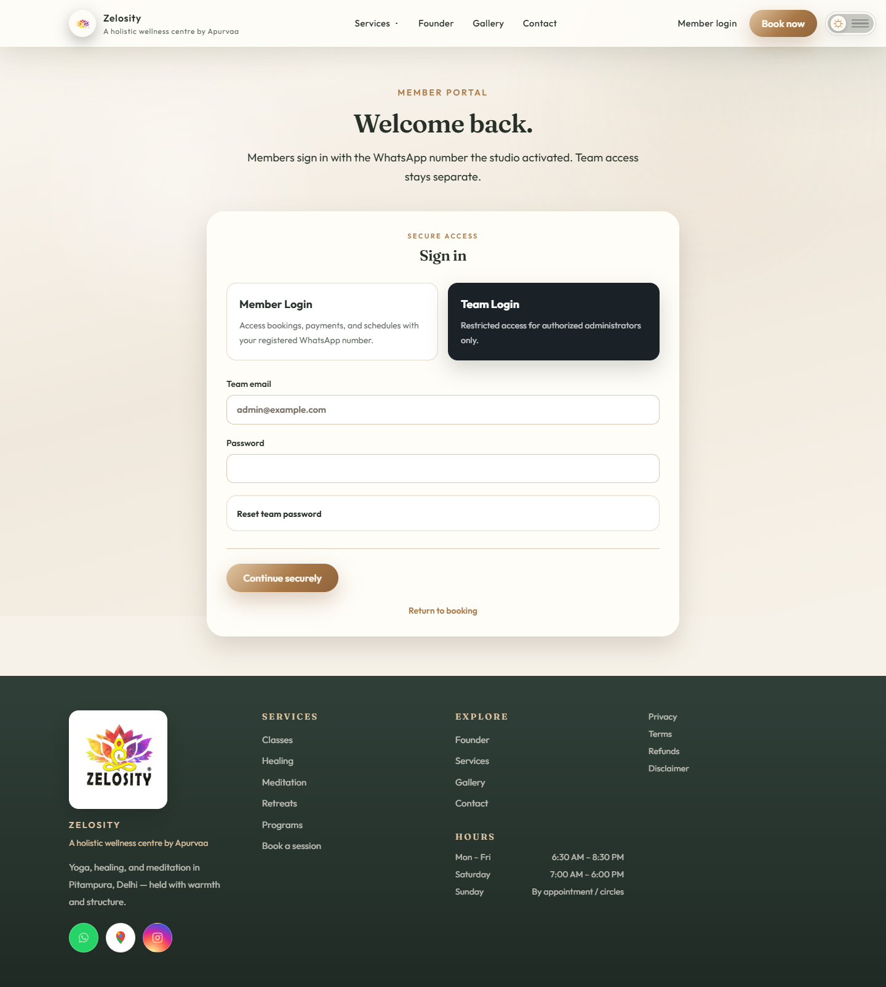
TC-ADMIN. Team login is email and password, not WhatsApp.
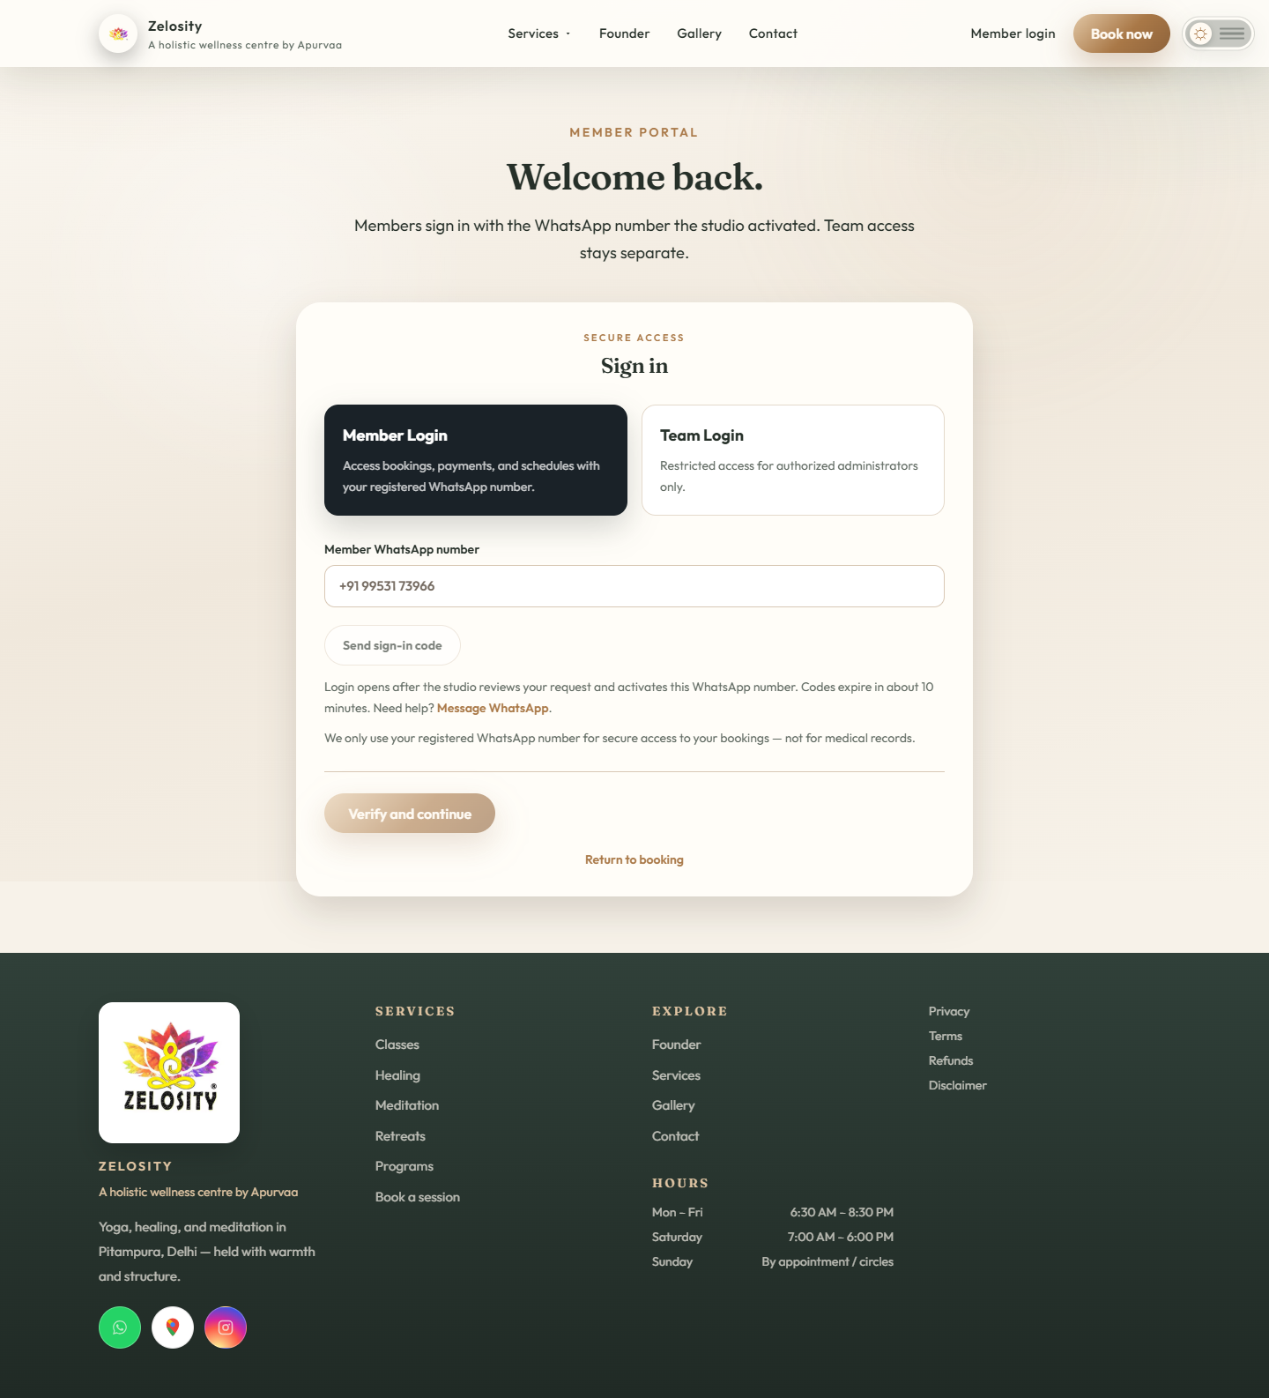
TC-ATT. Attendance URL sends an unsigned visitor to member login.
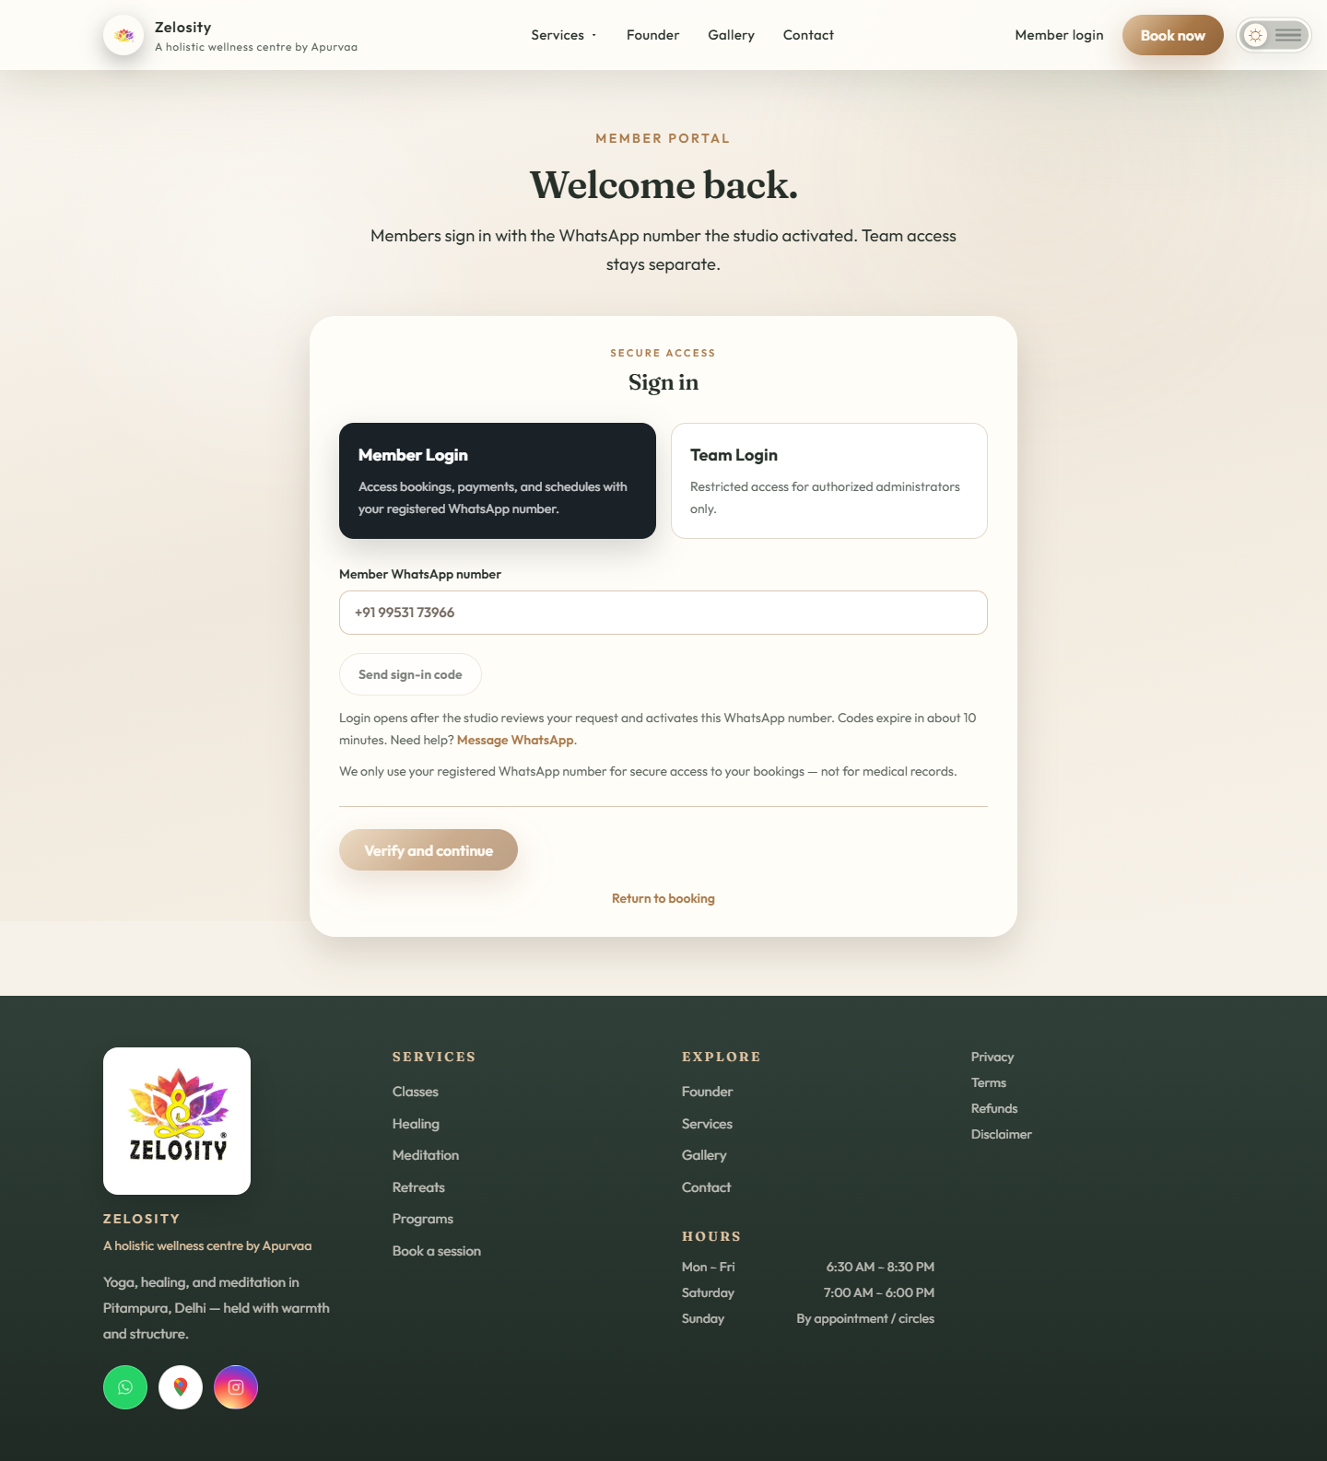
TC-ONB. Onboarding is required after first successful OTP.
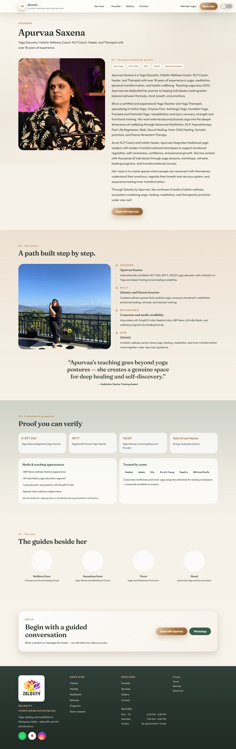
TC-FOUNDER. Founder story remains on the public site.
TC-MOBILE. Home page on a 390px viewport.

Client acceptance scenarios

Positive scenarios
ID | Scenario | Expected result
P01 | First-time visitor submits a valid booking while WhatsApp is available. | Booking is saved as Requested and can be reviewed by Admin.
P02 | First-time member requests and verifies a valid WhatsApp OTP. | Member account is created, number is marked verified, and dashboard opens.
P03 | Returning member signs in with the same number. | Existing account is reused and matching records appear without duplication.
P04 | Member requests a new code after the resend delay. | The newest code works and the older code is rejected.
P05 | Administrator confirms a requested booking. | Booking becomes Confirmed without collecting money automatically.
P06 | Administrator waitlists a full session and later promotes it. | Capacity is respected and status changes are retained.
P07 | Member submits a valid reschedule request and Admin approves it. | New date or mode is applied and capacity rules are reevaluated.
P08 | Administrator records a verified offline payment. | Payment label is updated and no online transaction is falsely created.
P09 | WhatsApp fails after a booking is submitted. | Booking remains stored and Admin continues service using the manual channel.
P10 | WhatsApp service recovers after an incident. | One controlled OTP test succeeds before automated delivery is restored.
P11 | Visitor submits Contact request; unactivated number tries Member login. | Login is rejected with a message to wait for studio activation.
P12 | Administrator clicks Activate WhatsApp login on that enquiry or booking. | Member account is invited. If Cloud API fails, the preview message is shown for manual share.
P13 | Activated member verifies OTP and completes onboarding (name, optional email, language, Terms, Privacy). | Dashboard opens. Email is optional. Same phone is the identity.
P14 | Member opens dashboard before paying. | Booking is visible. Attendance / QR remains locked with Payment due.
P15 | Admin marks paid or advance_paid, or issues an active pass. Member scans QR. | One AttendanceRecord is created. Admin roll and member profile match.
P16 | Classes and booking form show membership prices. | All membership amounts include 5% GST. Gold GST note is visible.
P17 | Returning activated member signs in again. | Onboarding is skipped. Existing records load by phone.
P18 | Transactional test data is wiped with reset-test-data. | Members, bookings, inquiries, OTPs, and attendance are removed. Admin, CMS, and templates remain.

Negative scenarios
ID | Scenario | Expected protection
N01 | Member enters an invalid or incomplete phone number. | Request is rejected with a clear formatting message.
N02 | Member enters an incorrect six-digit code. | Login is denied without revealing the correct code.
N03 | Member enters an expired, consumed, or superseded code. | Login is denied and a new code is required.
N04 | Member repeatedly guesses codes. | Challenge attempts and verification rate limits stop continued guessing.
N05 | Access token is expired or lacks permission. | Send code fails safely; no session is created.
N06 | Phone Number ID belongs to a different WABA. | Meta rejects the request and the application reports a temporary delivery failure.
N07 | Authentication template is unavailable or mismatched. | No unapproved message is substituted; login remains closed.
N08 | New production number is still Pending. | The deployment remains on staging or manual continuity mode.
N09 | Administrator tries to bypass a member OTP. | No bypass control exists; identity verification and an approved recovery path are required.
N10 | Administrator cancels a paid booking. | Cancellation does not silently refund or change the independent payment record.
N11 | Administrator changes a payment label without moving money. | The UI warns that the label is record keeping only; financial reconciliation remains required.
N12 | Member attempts to access another person’s records. | Dashboard data remains scoped to the authenticated phone or email.
N13 | Stranger requests OTP without studio activation. | 403: number is not activated. No account is created.
N14 | Member tries to scan QR with only a confirmed unpaid booking. | Check-in is refused. Payment due is shown.
N15 | Resend is in test mode and admin email is not the Resend account inbox. | Admin 2FA email fails. Do not treat this as a database outage.
N16 | Meta returns #131005 Access denied. | Invite and OTP sends fail. Keep records; share invite manually; do not enable public on-screen OTPs on the real domain.
N17 | Invite is sent as free-form text before the member has messaged the business. | Delivery can fail until a Utility invite template is approved.
N18 | NODE_ENV is written into Hostycare .env. | Next build / Passenger can break. Application mode must own NODE_ENV.

Production launch checklist
Gate | Required evidence | Owner
Business number | New number shows Connected in WhatsApp Manager and the display name has completed review. | Client and Meta
Asset alignment | Phone Number ID, WABA, app, system user, and token all belong to the intended production configuration. | Zelosity
Authentication template | Approved Authentication OTP template name, language, body parameter, and copy-code button match WHATSAPP_AUTH_TEMPLATE_NAME. One OTP template covers all member logins. | Client and Zelosity
Utility templates | Approve invite (required). Later: class reminder, waitlist added, waitlist promoted, package balance, retreat update. Do not create Meta templates for email receipts or extra OTP variants. | Client and Zelosity
Meta access | No #131005 in stderr.log. App is Live or every test recipient is allowlisted. Token has whatsapp_business_messaging. | Client and Zelosity
Resend domain | Studio domain verified. AUTH_CODE_EMAIL_FROM and NOTIFICATION_EMAIL_FROM are not onboarding@resend.dev. | Zelosity
GST prices | Classes and booking form show Includes 5% GST on every membership amount. | Client acceptance tester
Invite-only gate | Unactivated numbers cannot request OTP. Activated numbers can. Wipe script removes members without dropping admin or CMS. | Zelosity QA
Pay-first attendance | Unpaid confirmed booking is visible but QR is refused. Paid or active pass writes one shared AttendanceRecord. | Client acceptance tester
Secrets | Token and application secrets are stored only in the hosting environment; development-code exposure is disabled. | Zelosity
Positive test | Approved recipient receives the code and completes login; returning-member data is correct. | Client acceptance tester
Negative test | Invalid, expired, reused, and rate-limited codes are rejected without creating a session. | Zelosity QA
Continuity test | Booking is preserved and Admin can operate while WhatsApp delivery is intentionally unavailable. | Client operations
Payment reconciliation | Online and offline payment procedures are documented; cancellation and refund are tested separately. | Client finance and Zelosity
Incident ownership | Named contacts exist for Meta assets, application hosting, database, and client communications. | Client sponsor
Go-live approval | All gates are signed off and the rollback plan keeps the original WhatsApp Business App number untouched. | Client sponsor

Client decision points
1. Confirm that the new dedicated number will be used for Cloud API authentication and that the original number remains the human communication channel.
2. Choose whether the first production fallback will be verified email OTP or a one-time administrator recovery link. Email OTP is the simpler and safer default.
3. Approve the identity-verification policy for phone changes and exceptional recovery.
4. Define who may record offline payments, approve refunds, delete records, and close provider incidents.
5. Authorize production launch only after the Connected status and acceptance evidence are available.

Reference links
Meta WhatsApp Cloud API documentation
Meta phone registration reference
Meta authentication template documentation

