Heal With Apurvaa End to End Test Report
First visit, WhatsApp authentication, booking, administration, and validation coverage
Report field | Value
Prepared for | Heal With Apurvaa and Zelosity
Test date | 7 September 2026
Environment | Local release candidate at http://localhost:3005
Overall result | PASS WITH PRODUCTION CONDITIONS

Main conclusion
The local release candidate completed every final executed scenario successfully. A new visitor can navigate the public site, submit a booking, send an inquiry, save a consented wellness check-in, use the responsive mobile menu, and reach protected areas only after authentication. The supervised WhatsApp test-number flow delivered and read the approved authentication template, and the member login completed successfully.
The application is suitable for an internal or client demonstration. Production release should wait until the Prisma migration history is reconciled and the production-only payment, notification, domain, and recovery checks are completed.

Executive summary
Measure | Result | Interpretation
Executed checks | 36 of 36 passed | 24 positive, 11 negative, and 1 browser-runtime diagnostic
Automated regression | 35 of 35 passed | Nine Vitest files completed successfully
Code quality | Passed | ESLint and TypeScript no-emit checks completed without errors
Production readiness | Conditional | Resolve migration history and complete production-only integrations before launch

The final clean browser run passed 35 business scenarios and one runtime diagnostic. A separate focused rerun confirmed the administrator login and logout journey. Earlier exploratory runs exposed outdated expected copy and timing-sensitive automation assumptions; those test-script issues were corrected before the final result was recorded.

Test scope and method
- Started in a new Chromium browser context with no application session cookies.
- Executed desktop navigation at 1440 by 1000 pixels and mobile navigation at 390 by 844 pixels.
- Created clearly labelled local QA records for one booking, one inquiry, and one wellness check-in in the final run.
- Verified the live Meta test-number authentication flow in the supervised session without storing the temporary access token in project files.
- Ran the complete Vitest suite, ESLint, and the TypeScript no-emit compiler check.

Environment and test data
Item | Test value
Application | Next.js 16.2.10 with React 19.2.4
Database | Local PostgreSQL with Prisma 7.8.0
Browser | Google Chrome through Playwright Chromium automation
WhatsApp | Meta test WABA; sender masked as +1 555-***-1529
Recipient | Approved Meta test recipient ending in 3040
Notification mode | Local simulated delivery for booking notifications
Payment mode | Local Razorpay order creation disabled
Final booking | Request 3EB40D6F-A13 using QA-only contact data

Positive scenario results
ID | Scenario | Validation and observed result | Status
P-01 | First visit  Open the home page in a clean browser context | Expected: Home page loads with the public header and primary booking action  Observed: HTTP 200; hero, public navigation, contact details, service paths, testimonials, guides, footer, and booking actions rendered. | PASS
P-02 | Public navigation  Open /services | Expected: The page returns HTTP 200 and displays Clear paths into practice.  Observed: HTTP 200; expected page content displayed at /services. | PASS
P-03 | Public navigation  Open /classes | Expected: The page returns HTTP 200 and displays Daily practice, simply held.  Observed: HTTP 200; expected page content displayed at /classes. | PASS
P-04 | Public navigation  Open /healing | Expected: The page returns HTTP 200 and displays Private sessions, held with care.  Observed: HTTP 200; expected page content displayed at /healing. | PASS
P-05 | Public navigation  Open /meditation | Expected: The page returns HTTP 200 and displays Stillness you can return to.  Observed: HTTP 200; expected page content displayed at /meditation. | PASS
P-06 | Public navigation  Open /programs | Expected: The page returns HTTP 200 and displays Train, deepen, and share.  Observed: HTTP 200; expected page content displayed at /programs. | PASS
P-07 | Public navigation  Open /retreats | Expected: The page returns HTTP 200 and displays Step away. Soften. Return renewed.  Observed: HTTP 200; expected page content displayed at /retreats. | PASS
P-08 | Public navigation  Open /gallery | Expected: The page returns HTTP 200 and displays Moments from the practice.  Observed: HTTP 200; expected page content displayed at /gallery. | PASS
P-09 | Public navigation  Open /founder | Expected: The page returns HTTP 200 and displays Apurvaa Saxena  Observed: HTTP 200; expected page content displayed at /founder. | PASS
P-10 | Public navigation  Open /contact | Expected: The page returns HTTP 200 and displays Book in three calm steps  Observed: HTTP 200; expected page content displayed at /contact. | PASS
P-11 | Public navigation  Open /check-in | Expected: The page returns HTTP 200 and displays Find a gentle next step for your current state.  Observed: HTTP 200; expected page content displayed at /check-in. | PASS
P-12 | Public navigation  Open /privacy | Expected: The page returns HTTP 200 and displays Privacy  Observed: HTTP 200; expected page content displayed at /privacy. | PASS
P-13 | Public navigation  Open /terms | Expected: The page returns HTTP 200 and displays Terms  Observed: HTTP 200; expected page content displayed at /terms. | PASS
P-14 | Public navigation  Open /refund-policy | Expected: The page returns HTTP 200 and displays Refund  Observed: HTTP 200; expected page content displayed at /refund-policy. | PASS
P-15 | Public navigation  Open /wellness-disclaimer | Expected: The page returns HTTP 200 and displays Wellness  Observed: HTTP 200; expected page content displayed at /wellness-disclaimer. | PASS
P-16 | Classes  Filter the class schedule by period and mode | Expected: Visible class results update without a page error  Observed: 5 class result link(s) remained after Morning and Studio filters. | PASS
P-17 | Offer journey  Open a class detail and continue to booking | Expected: The booking page opens with the selected class prefilled  Observed: Offer action opened http://localhost:3005/contact#booking with a preselected booking option. | PASS
P-18 | Gallery  Filter gallery and open and close an image | Expected: The category filter updates and the accessible lightbox opens and closes  Observed: A category filter was applied; the lightbox opened with dialog semantics and closed successfully. | PASS
P-19 | Booking  Submit a complete three-step booking request using QA-only contact data | Expected: A request number and expected response time are shown  Observed: Booking request 3EB40D6F-A13 was created; confirmation states a response within four business hours. | PASS
P-20 | Inquiry  Submit a general inquiry with QA-only data | Expected: The form confirms the question was sent  Observed: Inquiry API returned HTTP 201 and the success message appeared; delivery is configured for local simulation. | PASS
P-21 | Wellness check-in  Change the recommendation inputs and save with consent using QA-only data | Expected: The recommendation updates and the check-in is saved  Observed: Recommendation controls updated and the consented QA check-in was saved. | PASS
P-22 | Admin authentication  Sign in with the seeded local administrator and open the workspace | Expected: The admin workspace loads and the session can log out  Observed: Seeded administrator authenticated, workspace rendered, and logout ended the session. | PASS
P-23 | Responsive layout  Open the home page at a 390 pixel mobile width | Expected: The mobile menu is available and the page has no material horizontal overflow  Observed: Mobile menu opened; horizontal overflow was 0px. | PASS
P-24 | WhatsApp Cloud API  Request and complete WhatsApp one-time-code login using the Meta test number | Expected: Meta accepts the template message and the user reaches the member area  Observed: Approved authentication template delivered through test phone ID 1267762983090414; user confirmed the login flow worked. | PASS

Negative scenario results
ID | Scenario | Validation and observed result | Status
N-01 | Access control  Open the member dashboard without a session | Expected: The browser is redirected to member login  Observed: Unauthenticated request redirected to http://localhost:3005/login?role=member&redirect=/dashboard. | PASS
N-02 | Access control  Open the admin workspace without a session | Expected: The browser is redirected to team login  Observed: Unauthenticated request redirected to http://localhost:3005/login?role=admin&redirect=/admin. | PASS
N-03 | WhatsApp login  Enter an invalid phone value | Expected: The API rejects the request locally and no WhatsApp message is sent  Observed: Invalid value was rejected with: Enter a valid WhatsApp number with country code, for example +91 98765 43210. | PASS
N-04 | Admin authentication  Submit incorrect administrator credentials | Expected: Access is denied and the browser stays outside the admin workspace  Observed: Incorrect password was rejected with HTTP 401: Admin email or password is incorrect. | PASS
N-05 | Booking validation  Attempt to continue without required visitor details | Expected: Continue remains disabled until name, phone, email, and date are present  Observed: The Details-step Continue button remained disabled with missing required fields. | PASS
N-06 | Booking validation  Post malformed booking data directly to the public API | Expected: The API returns HTTP 400 with field errors  Observed: HTTP 400 with 5 field errors. | PASS
N-07 | Inquiry protection  Submit a honeypot inquiry | Expected: The API rejects the automated submission  Observed: The honeypot returned the deliberate neutral HTTP 200 response and did not enter normal inquiry creation. | PASS
N-08 | Check-in consent  Attempt to save a check-in without consent | Expected: The form reports that consent is required  Observed: The save was blocked and a consent-related validation message was displayed. | PASS
N-09 | Error handling  Open a route that does not exist | Expected: The application returns its not-found page without a runtime crash  Observed: HTTP 404 with the application not-found page. | PASS
N-10 | Certificate verification  Open an unknown certificate identifier | Expected: The verification page reports that the certificate is invalid or unavailable  Observed: Controlled response returned HTTP 404 with certificate status text. | PASS
N-11 | WhatsApp Cloud API  Send a code to a number outside the Meta test recipient allowlist | Expected: Meta rejects the recipient without sending a message  Observed: Meta returned error 131030 Recipient phone number not in allowed list. | PASS

Diagnostic result
ID | Scenario | Validation and observed result | Status
D-01 | Browser runtime  Review uncaught page errors | Expected: No uncaught page errors  Observed: No uncaught page errors were recorded during the browser run. | PASS

Automated verification
Check | Command | Observed result | Status
Vitest | npm test | Nine test files and 35 tests passed | PASS
ESLint | npm run lint | Completed with no lint errors | PASS
TypeScript | npx tsc --noEmit | Completed with no compiler errors | PASS
Database status | npx prisma migrate status | Migration history differs from the local repository | ACTION

Defects and readiness observations
ID | Severity | Area | Observation and required action | Status
R-01 | High | Database migration history | The database contains six migration records not present in the repository, while two repository migrations are reported as unapplied. Reconcile and rehearse the production migration path before deployment. | Open
R-02 | Medium | Outdated UAT instructions | WEB_TEST_SCENARIOS.md still lists earlier page headings and the previous email or local dev-code member login. Update it to the WhatsApp number flow and current page copy. | Open
R-03 | Low | Development server stability | One exploratory high-frequency navigation run returned a temporary HTTP 500 with an Unexpected end of JSON input message. The issue did not recur in the final clean run and was observed only in Next.js development mode. | Monitor

Production-only scenarios not executed
- Real Razorpay order creation, payment authorization, capture, refund, and webhook reconciliation.
- External email and WhatsApp delivery generated by booking, reminder, pass-balance, and lifecycle notifications; this local run used simulated delivery.
- Production domain, HTTPS, secure cookies, reverse proxy behavior, and public tunnel restrictions.
- Destructive restore rehearsal, backup recovery timing, and disaster-recovery validation.
- Production-volume rate, concurrency, accessibility, and cross-browser testing beyond Chrome desktop and the 390-pixel mobile viewport.

Production readiness checklist
Step | Action | Gate
1 | Reconcile Prisma migration records and verify a clean deploy against a production-like database | Required
2 | Update WEB_TEST_SCENARIOS.md for current headings and WhatsApp authentication | Required
3 | Configure production secrets, approved WhatsApp assets, webhook verification, and a permanent token strategy | Required
4 | Run Razorpay in test mode through order, authorization, verification, webhook, and refund | Required
5 | Verify real notification providers with approved test recipients and templates | Required
6 | Build and smoke-test the production artifact behind HTTPS | Required
7 | Rehearse backup and restore in a disposable production-like database | Required
8 | Repeat the final first-visit, member, and admin journeys on the deployed staging URL | Required

Execution evidence
The following images were captured during the final browser execution. Phone numbers and access tokens are not shown.
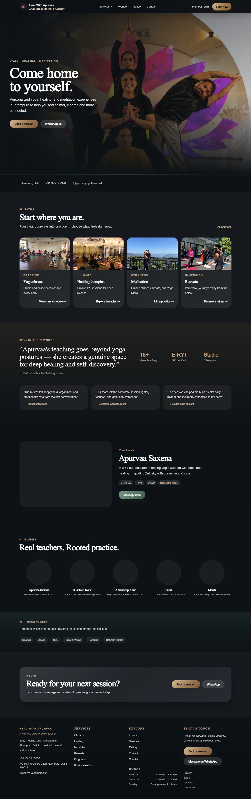
Figure 1 Clean first visit to the public home page
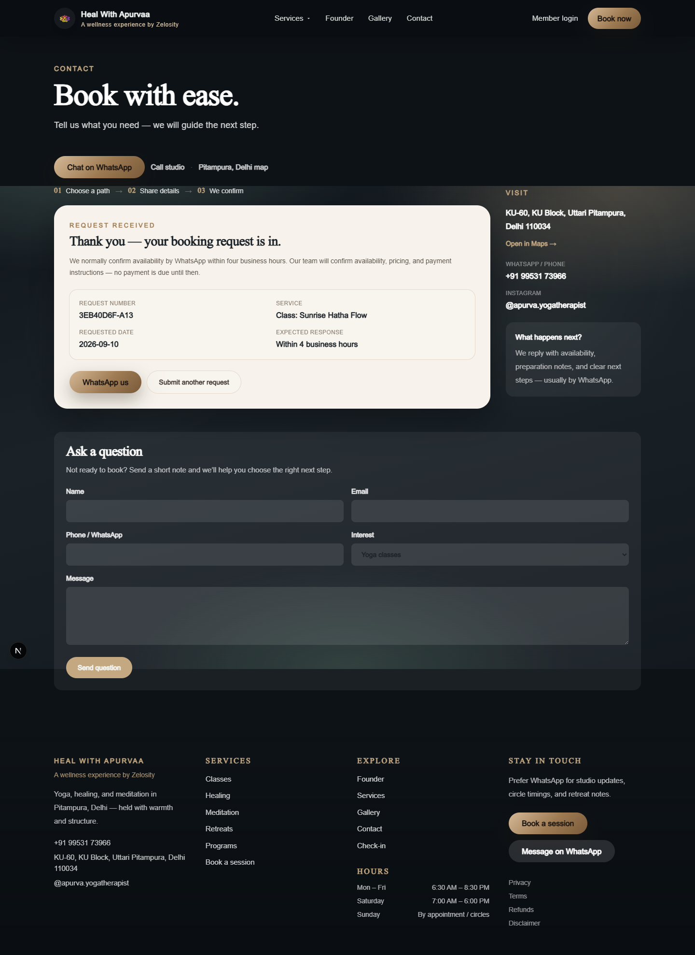
Figure 2 Completed local booking request with request number
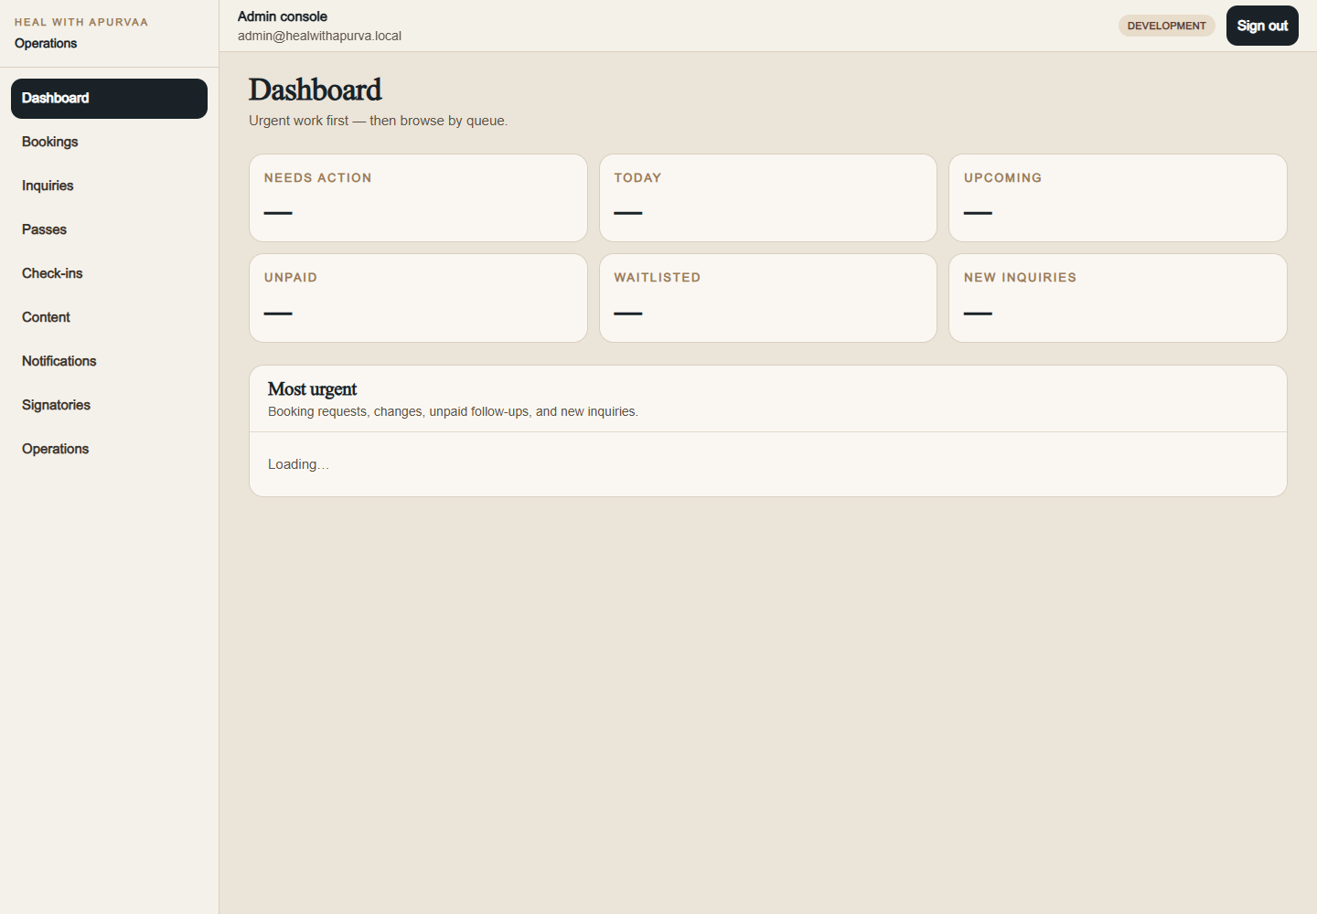
Figure 3 Authenticated administrator workspace
Figure 4 Mobile menu at 390 pixels with zero horizontal overflow

Decision
Approve the application for internal and client demonstration using the current local test setup. Do not approve the production launch until R-01 and R-02 are closed and every production-only scenario listed above has an evidence-backed result.

